The Southern Ranges Branch manages 98 parks and reserves, including Kosciuszko National Park, the largest park in New South Wales. Our parks are home to the NSW alpine ski resorts, which attract a high number of visitors in the winter months.
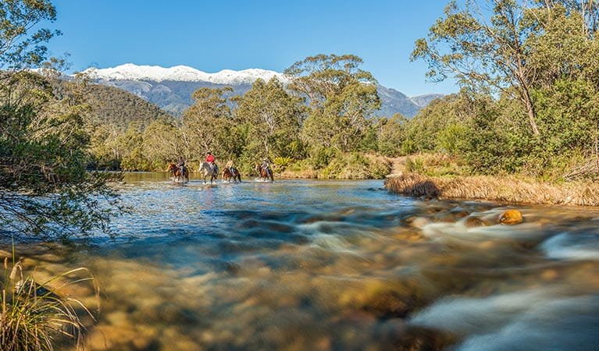
Kosciuszko National Park
From the tablelands of the Monaro Plain to the high-altitude alpine areas of Kosciuszko and Brindabella national parks, our branch covers one of the most geographically and biologically diverse areas in the state.
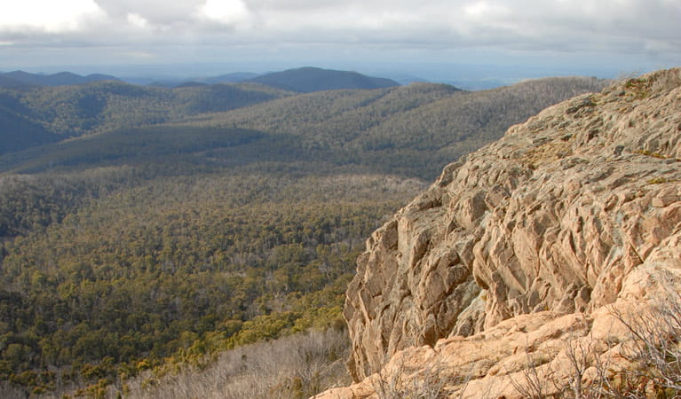
Brindabella National Park

