The Hunter Central Coast Branch manages 136 parks and reserves that are home to unique plants and animals, such as the threatened Gould's petrel. Our parks and reserves include significant sites such as the Gondwana Rainforests World Heritage Area and the Aboriginal-owned Worimi Conservation Lands.
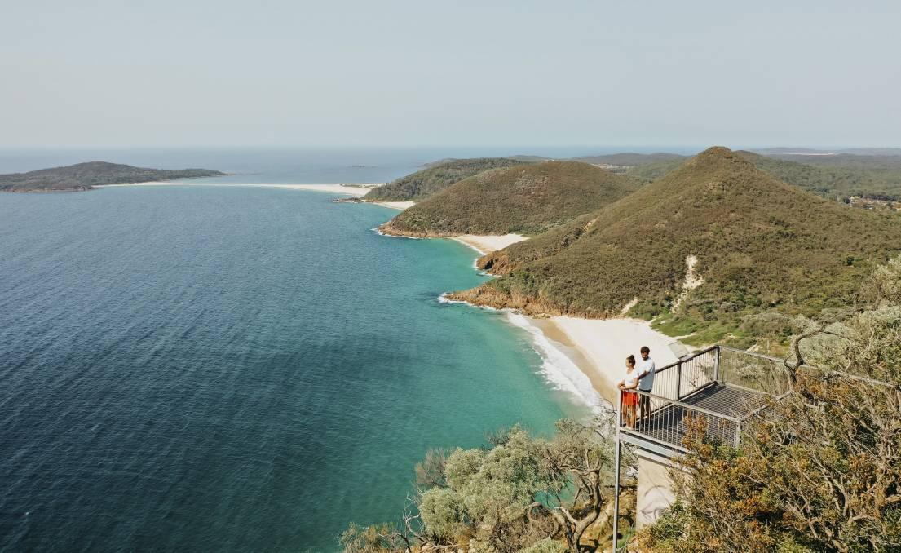
Tomaree Coastal Walk
Over 8.3 million people annually visit the national parks of this region. We manage over 40 campgrounds and maintain more than 3,100 km of roads and trails. Highlight projects include the $6.7 million Tomaree Coastal Walk in Port Stephens.
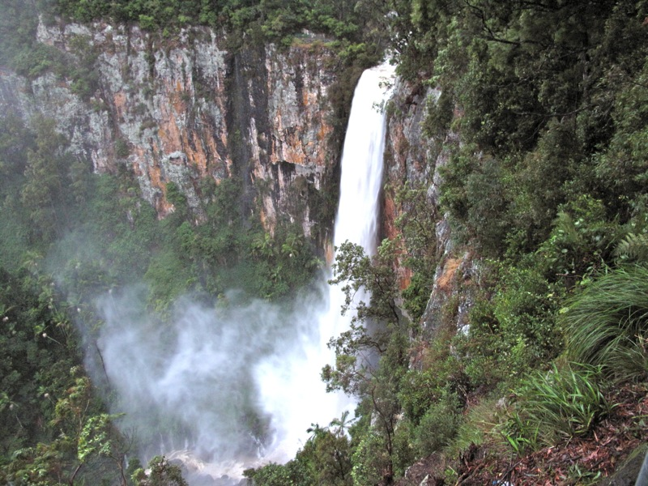
Gondwana Rainforest

