The Northern Inland Branch manages 167 parks and reserves in some of NSW most diverse and spectacular landscapes, ranging from World Heritage rainforest, sub-alpine forests, gorges and wild rivers, internationally recognised wetlands, wilderness areas to semi-arid environments.
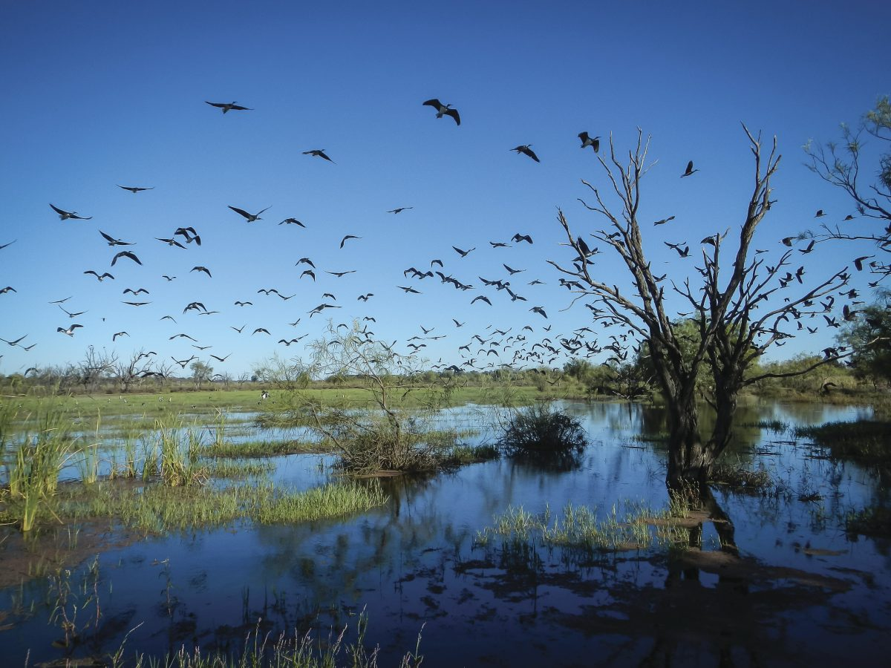
Gwydir Wetlands
We protect over 250 threatened species and 22 endangered ecological communities and manage 88 visitor areas and 47 campgrounds. We live and work in vibrant rural communities and collaborate with a broad range of stakeholders, including Aboriginal joint management committees.

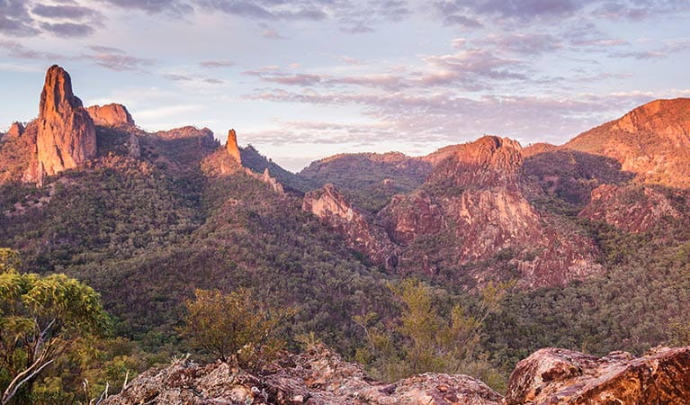
Warrumbungle National Park

